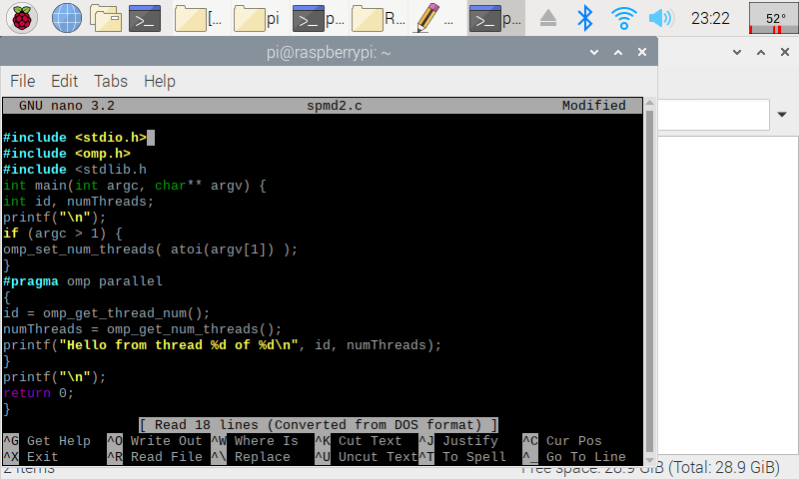

This code is before we dedicate ids to each thread which doesn’t result in full variable declarations. After setting this however, the threads had a separate id for each one. In the code below it is not set to numerical order as each thread completes at different intervals.

In the code above it’s interesting to note that the string formatting used reflects in higher level languages, and it’s also interesting to notice the allocation set in the beginning lines, as we introduce new libraries and new managements.

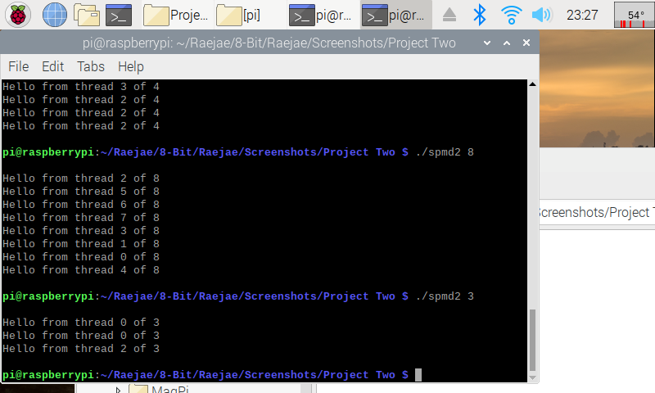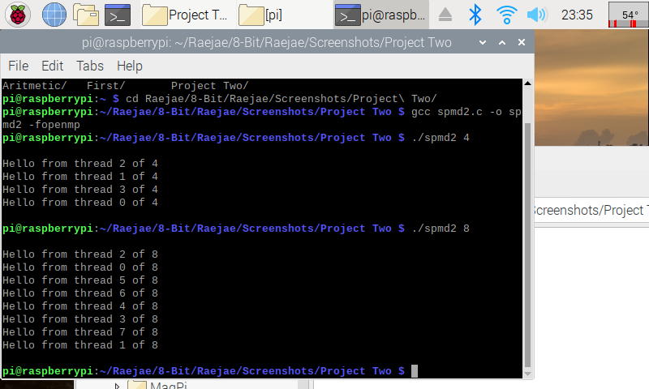After assembling the file and running, we notice that different threads in a series of four are implemented on the same memory bank. This is bad because for optimization and doesn’t split the threads as we need it. To fix this we referenced the variables in the code to allow each thread a separate memory bank and verified as displayed.